Rhonda’s
Spicy Mango Chutney

Welcome to Rhonda’s Spicy Mango Chutney.
We present here from local to national favourite recipes that’s really yuummm to
your taste and of course fits your budget.
Variations of the recipe are encouraged and of course anyone can suggest or make their very own recipe.

ADOBO (chicken)

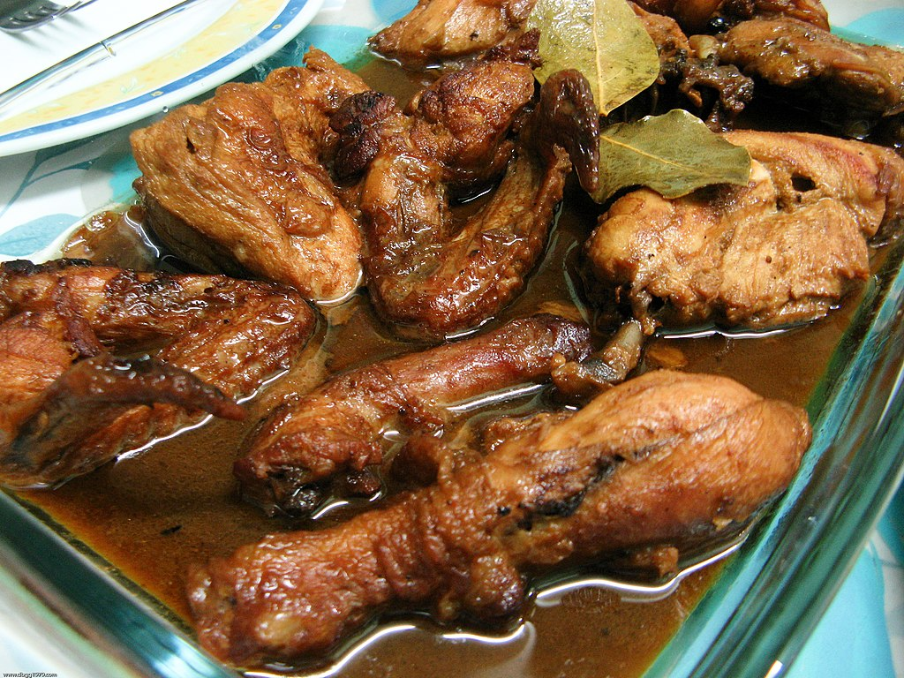
View Recipe

Print Recipe

Pork Adobo
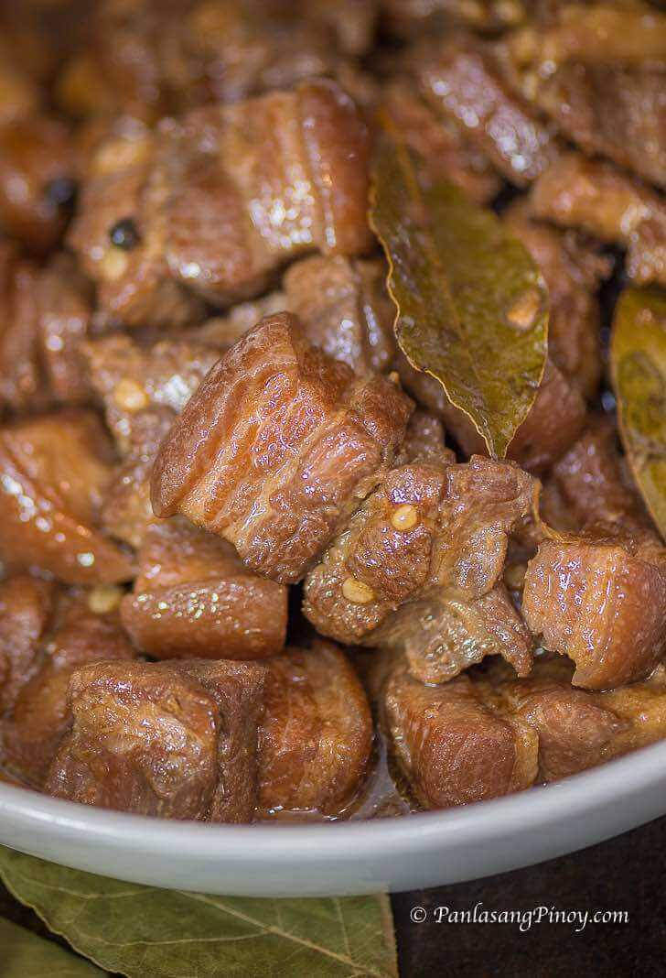

View Recipe

Print Recipe

